**AWS Certification :**

1. **Types of Certifications :**

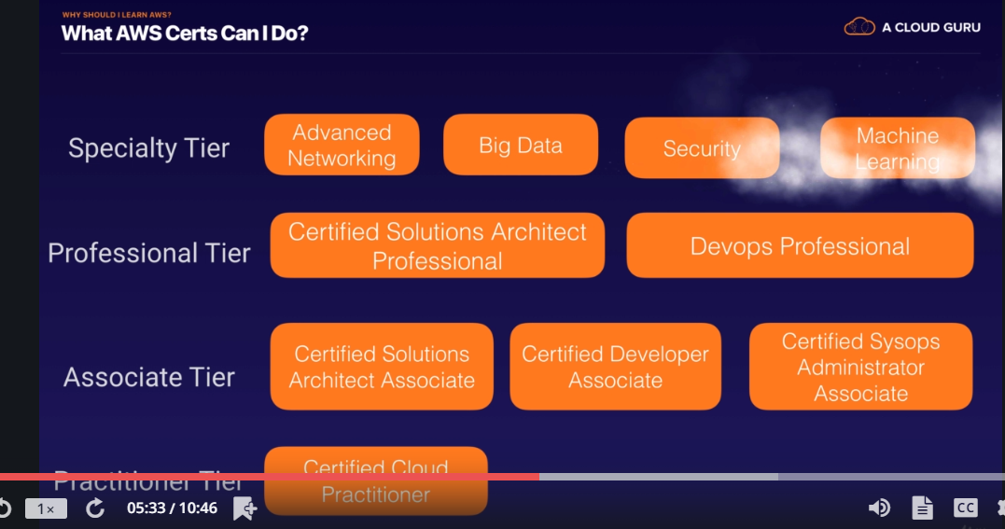

1. **AWS new features**

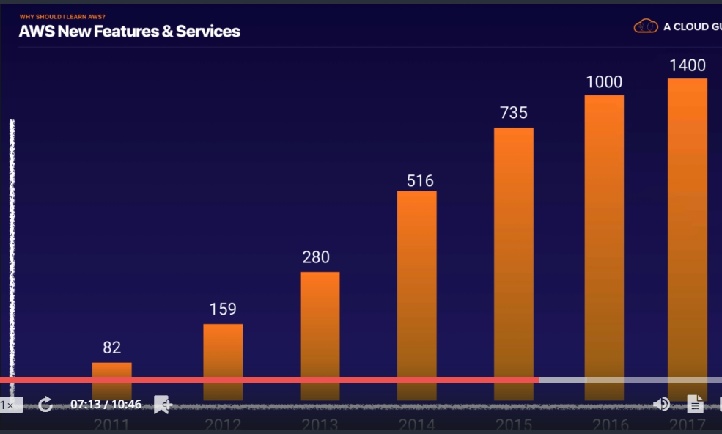

1. **Exam blue print**

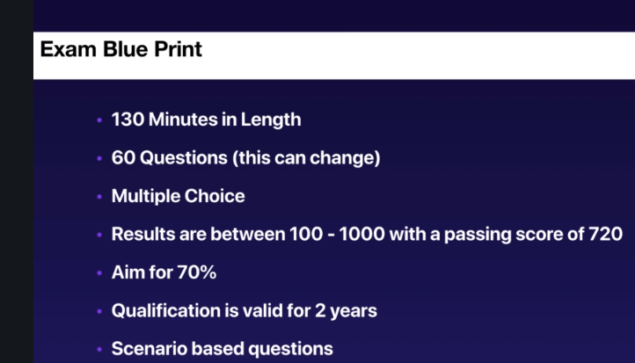

1. **Exam booking.**

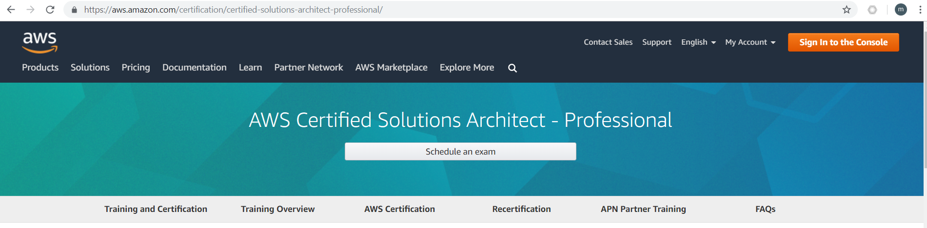

1. **AWS High level Services**

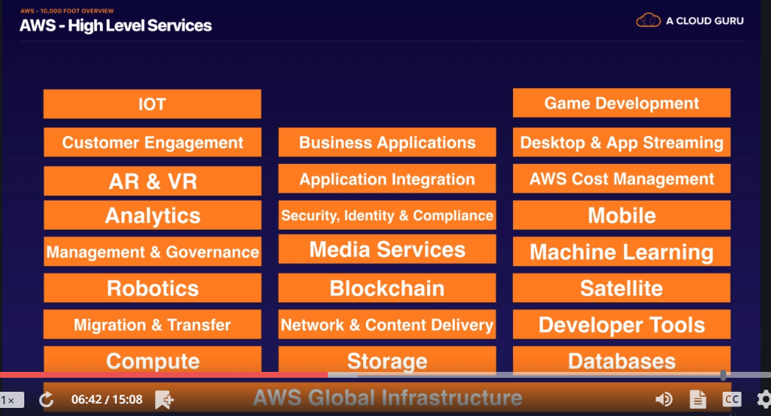

1. **AWS Global Infrastructure**

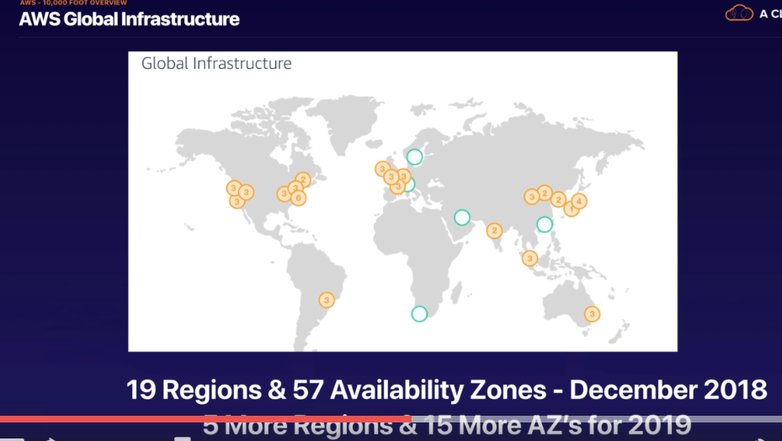

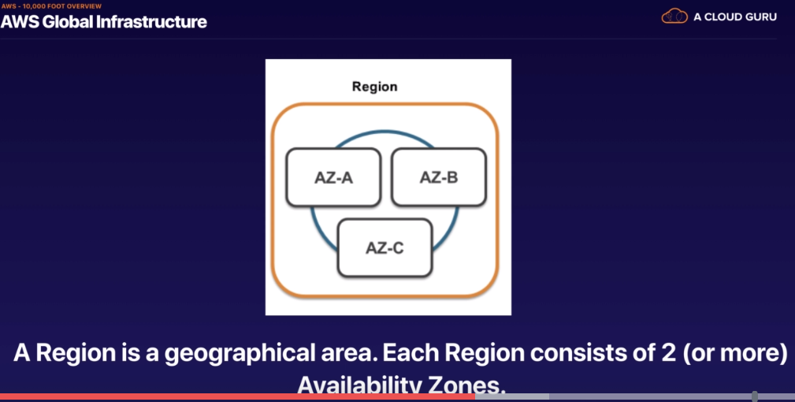

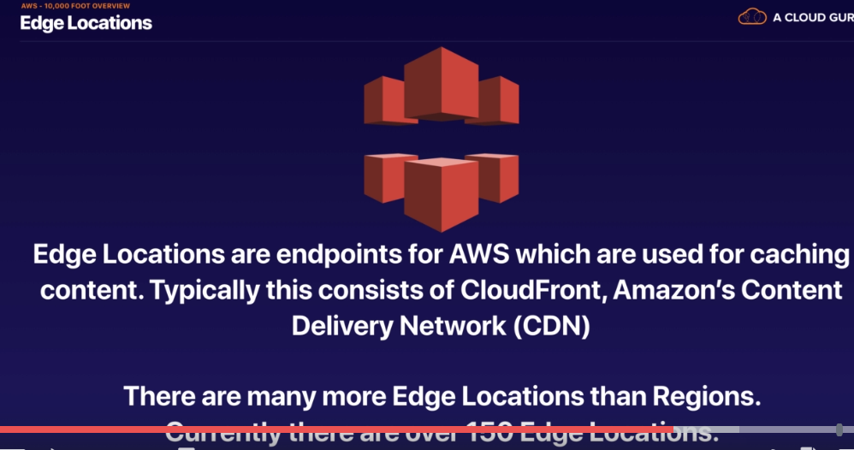

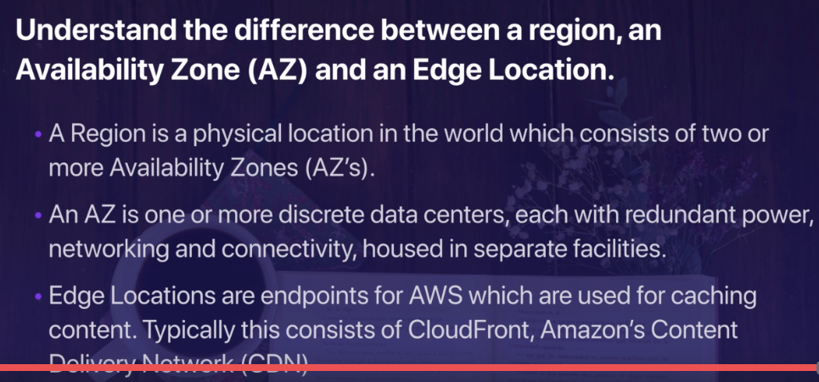

1. **Exam Content**

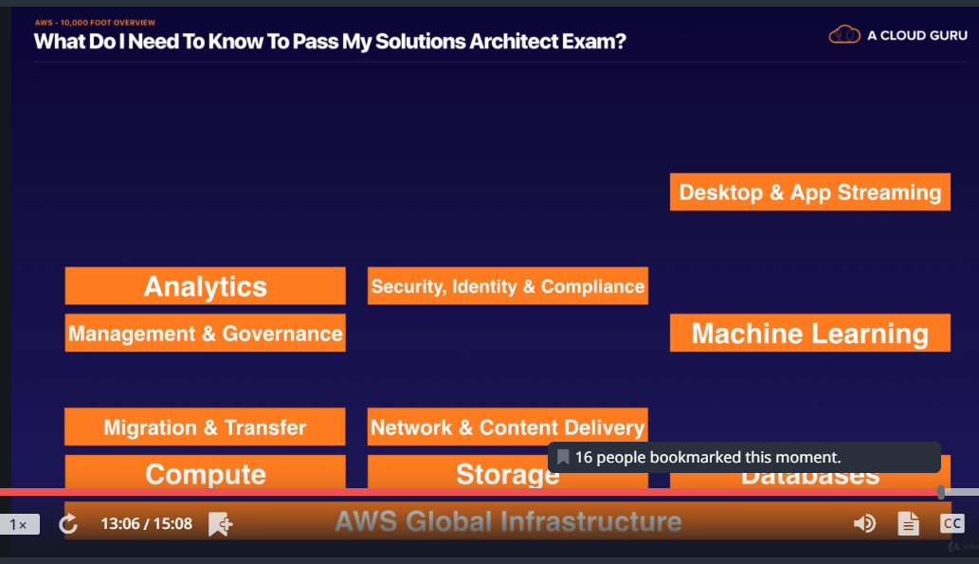

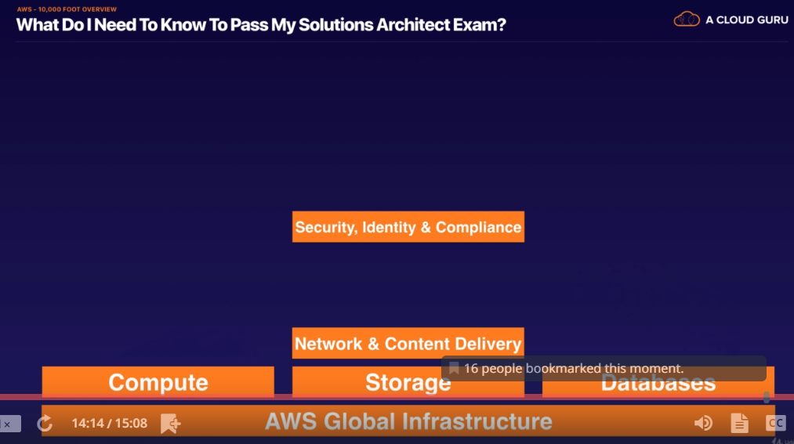

1. **IAM**
2. **User:**
3. **Group: combination of users**
4. **Policies :Controls actions works b/w users and Resources**
5. **Roles : Works b/w aws resources.**
6. **Create A Billing Alarm**
7. **AWS S3 Storage.**

